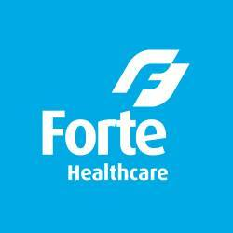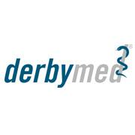
Derbymed Amateur Spring Tour

Showjumping Ireland are delighted to announce the Launch of a new Amateur Spring Tour kindly sponsored by Derbymed. The tour will consist of 7legs nationwiderunning from February 2020 – April 2020 and will run on a league table basis with points and a half allocated at the final.
The final will be held at Coilog Equestrian on the 19th April 2020 in conjunction with the Showjumpers Club Spring Tour Grand Prix final where over €2000 worth of prizes will be on offer kindly sponsored by Derbymed.
Speaking on behalf of Debymed; Cristhiane Krym said: “We are delighted to once again support Show Jumping Ireland, and look forward to this year’s Derbymed Amateur Spring Tour.”Present on the day of the launch at JAG equestrian, Val Joy said “It’s fantastic to see this new league come into place and give the Amateur category a boost with something new and exciting for this time of year. The first leg of the league is this Sunday the 23rdFebruary in Cavan Equestrian and I encourage everyone to get their entries in and kick off the 2020 Amateur season. I would also like to thank Derbymed for their support towards show jumping and their commitment to Amateur Riders nationwide.

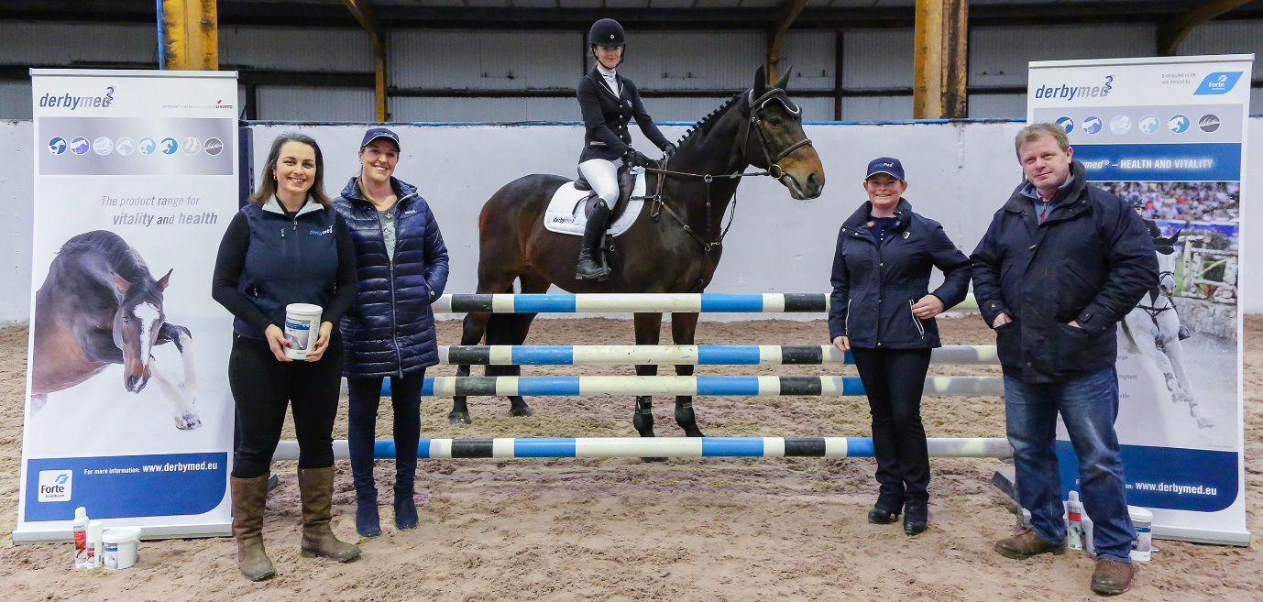
Pictured L-R: Cristhiane Krym (Derbymed), Amateur Riders; Val Joy& Michelle Clifford, Julieann Gaffney (JAG Equestrian) and Chair of the Showjumpers Club; Ronan Corrigan

Venues
23rdFebruary 2020 : Cavan Equestrian Centre
15th March 2020 : Killossery Lodge Stud
17th March 2020 : Meadows Equestrian
29th March 2020: Kernans Equestrian
8thApril 2020 : JAG Equestrian
12th April 2020 : Mullingar Equestrian
Final : 19th April 2020 : Coilog Equestrian Centre

Please see www.sji.ie for details on the league format.

